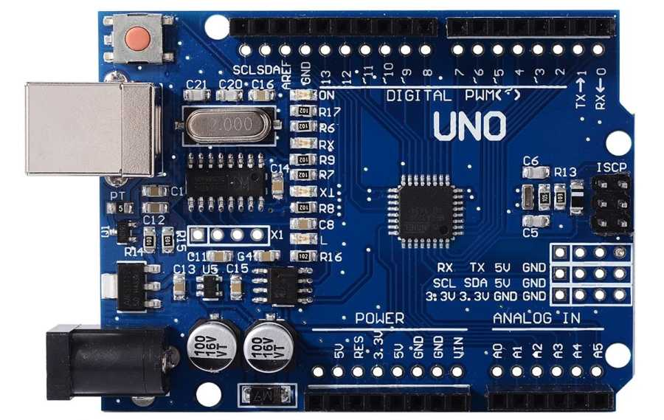

:Theory:

**Concept Used:**

The basic concept of the circuit that is used here is based on giving input and receiving output. So accordingly when an input is given the circuit gives an output as per the logic embedded. The output is obtained in the form of flashing LED. The LED flashes according to the instruction uploaded in the arduino board by the user. The board consists of a set of digital and analog input and output pins. All the instructions vvgiven by the board are programmed using C programming language. For this experiment we used digital pin 13 as output.

The positive terminal of the LED is connected to the digital pin 13 and the negative terminal is connected to the ground of the arduino board.

**Learning & Observation:**

This experiment gave me an insight into circuit boards. This insight has helped me to distinguish between the input and output pins of a board easily. It had also taught me to upload a program into a circuit board. This experiment had also made me familiar with how to blink an LED by uploading simple two line program written in C. I also learnt first hand as to how we can affect the blinking of the LED with a simple code.

**Problems & Troubleshooting:**

Being the first time that i had attempted this experiment, I was unable to upload the program into the arduino board though the program was correct. This occurred because of the board and port selection. This problem troubleshooting was done by selecting the correct board from “Tools” option and also the port in the arduino software.

**Precautions:**

Precautions that should be taken in this project are given below :

• Make sure that the board and port in the “Tools” option in arduino are selected correctly.

• The arduino board should be handled carefully to avoid damage.

• The program should be small with low inbuilt memory.

• Carefully connect the positive terminal to the output pin of the circuit for the LED to work properly.

**Learning Outcomes:**

This experiment has given me insights into arduino board and it's working. It has taught me how to control outcomes work simple programs.

Now, using the learnings from this experiment, i can attempt varied outcomes by slowly increasing the complexities of the program. This experiment can be a stepping stone to attempt various other outputs from the board.